**FREETARGET**

Application Note: Suis Target Plate Installation

# REQUIRED

* Pistol target plate
* 2 x 5mm x 50mm machine screws
* 2x 3D printed alignment pins

# ASSEMBLY

* Remove the pistol plate and remove the existing paper holder
* At the locations shown in Figure 1, insert the alignment pegs

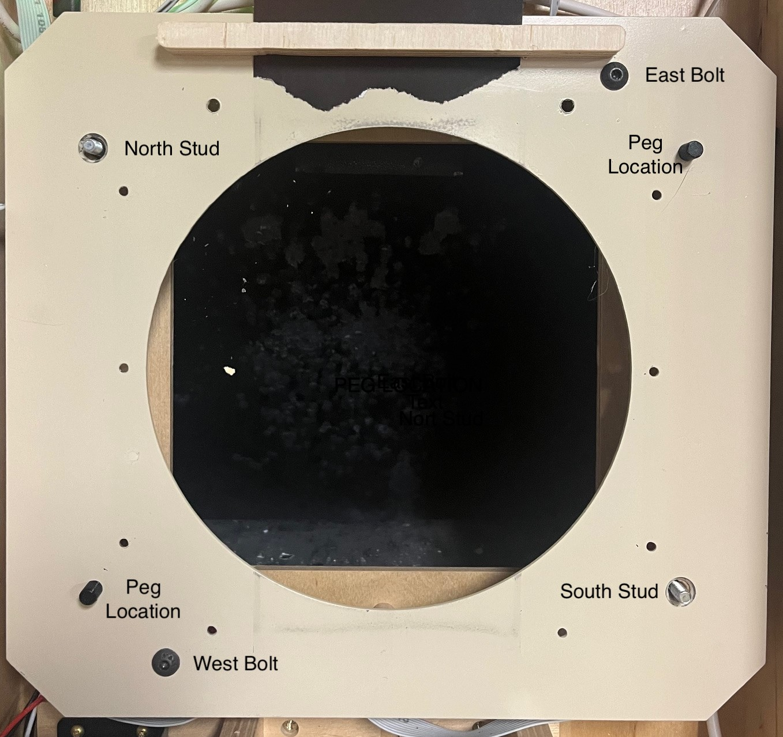

Figure 1: Component Location

* Insert the aligment pegs as shown in Figure 2. The pegs will be slightly tight, but will install with a light tap.
* From the back, hold the peg in place with the grommet as shown in Figure 3. The grommet will have a tight fit and may need to be pushed into place with a light hammer

|  |  |
| --- | --- |
|  |  |
| Figure 2: Aligment Peg | Figure 3: Retention Grommet |

* Reattach the plate to the target using the East and West bolts, same as a regular target
* From the rear, insert the 50mm bolts through the sensor mount. When finished about 10mm should protrude.

# INSTALLING TARGETS

The target is assembled onto the target place as shown in Figure 4.

Target Plate

Suis target backer (usually an old target

Witness paper

Fresh Suis target

You may wish to hold the target in place with magnets or tape

Note, the paper on the threaded studs in North and South will be loose, but tightly aligined on the plastic studs

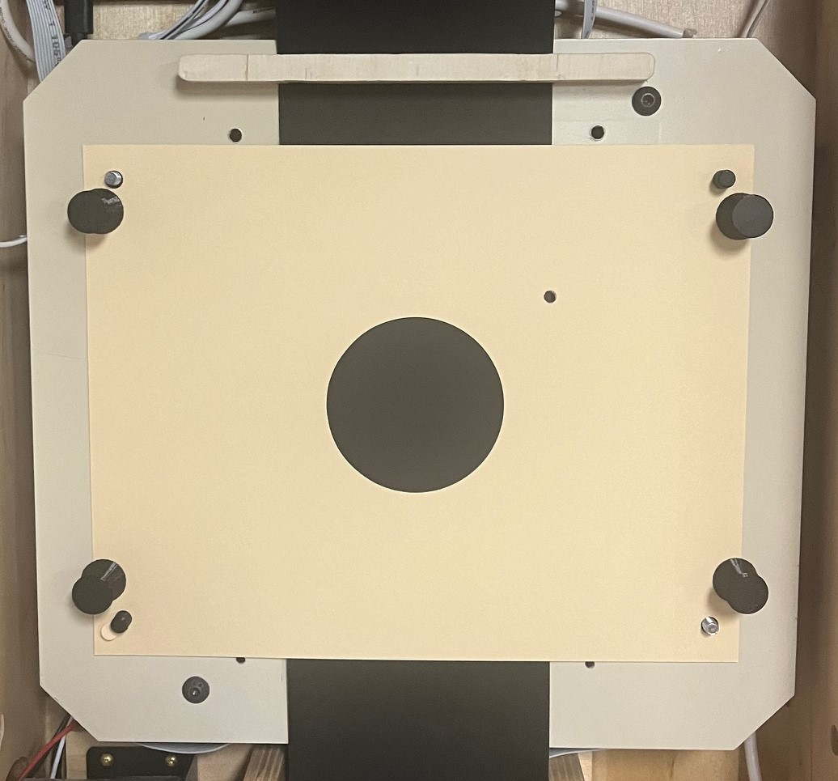

Figure 4: Target Assembly